**INFM 600 – PROJECT PLAN – Stack Overflow User Analysis**

**Description of Data**

The dataset presents Annual Developer Survey results for the Stack Overflow Users (developer community) getting specifics about their background, skillsets, knowledgebase, technology expertise, job satisfaction/expectations and income statistics.

**Research Questions**

1. Job satisfaction comes with more salary compensations/expectations?
2. If large Multinational Corporations want to offshore their workload, which countries can be suitable in terms of logistics and workforce?
3. Does location affect the skillsets and technical expertise?
4. Does the number of years in a job affect the workers’ willingness to switch?
5. To check stability in a person based on years of work, competencies, age, salary and last switch to control attrition.
6. Do people use sites like stack overflow to find new jobs?

**Planned Timeline and Effort Allocation**

|  |  |  |  |  |  |  |
| --- | --- | --- | --- | --- | --- | --- |
| **Week** | **Task** | **Status** | **Abhimanyu** | **Rishi** | **Jhon** | **Comments** |
| Week 6 | Preparation of Research Questions |  | Draft 2 questions | Draft 2 questions | Draft 2 questions |  |
| Week 7 | Data Cleaning and Finalizing of Population for Analysis |  | Collaborative Work | | |  |
| Week 8 | Analysis for Questions |  | Analysis for Question 1 | Analysis for Question 2 | Analysis for Question 3 |  |
| Week 9 | Analysis for Questions |  | Analysis for Question 4 | Analysis for Question 5 | Analysis for Question 6 |  |
| Week 10 | Meeting with Instructor/Project Updates |  | Collaborative Work | | |  |
| Week 11 | Visualize Findings |  | Visual for Question 1 & 4 | Visual for Question 2 & 5 | Visual for Question 3 & 6 |  |
| Week 12 | Draft Final Presentation |  | Cross Analysis Verification and Validation | | |  |
| Week 13 | Draft Final Report |  | Collaborative Work | | |  |
| Week 14 | Finalize Project Deliverables |  | Draft Documentation | Requirement Specification | Verification and Final Documentation |  |
| Week 15 | Final Project Presentation |  | Collaborative Work | | |  |

**Gantt Chart**

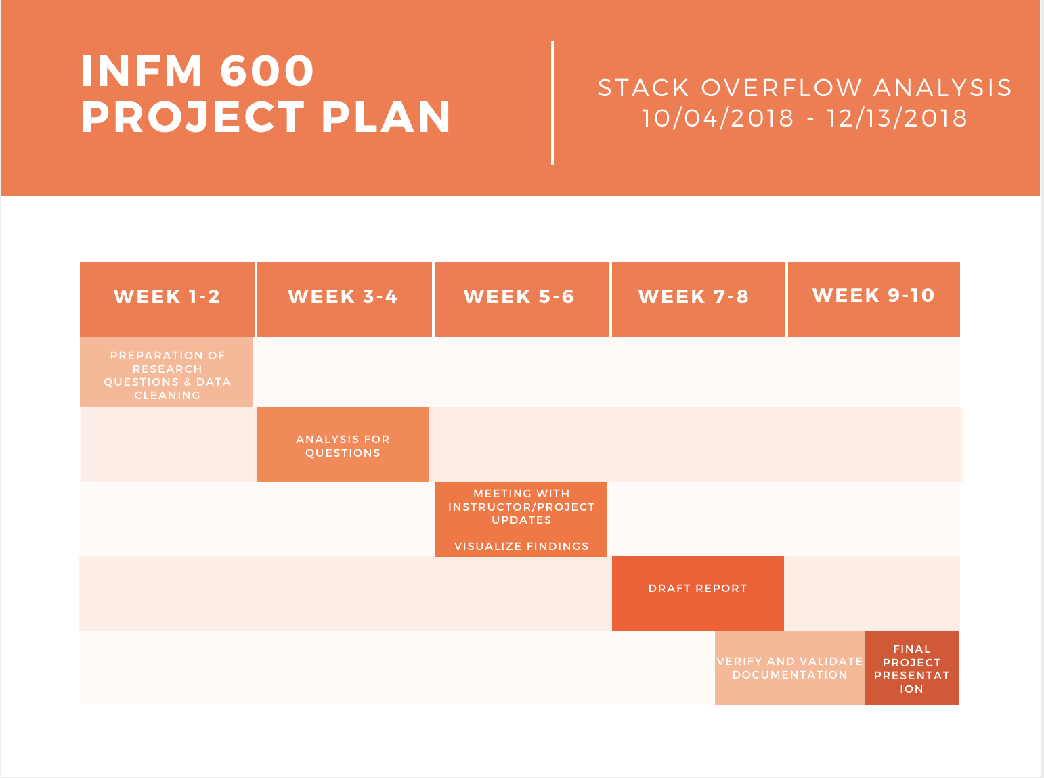

**Target Audience for the Analysis**

Analysis through the dataset selected for this project has a wide range of users from a variety of demographics who can utilize analysis results to fulfil their requirements. Listed below are the possible target audience:

1. Companies looking for hiring and team planning.
2. Multinational Companies planning to open offshore offices.
3. Organizations utilizing the analysis reports to improve employee retention.
4. Educational Organizations and researchers can use the statistical analysis for specific locations having workforce of higher or lower quality competencies, and plan for improvements accordingly.
5. Help aid the Coders and developers looking for jobs or switch to understand the lacking competencies and salary schemas to improve and plan their career.
6. Online platforms like stack overflow to analyze the pattern of developers and provide a solution to benefit the users/developers.

Word Count: 408